**Name:** Siddhant M Mangale  
**Class:** B.Tech **Div:** A  
**Roll No:** 31

**Experiment No. 1**

Aim: To implement Julia Program for Data Analysis with Basics of Julia

1. Write a Julia program to demonstrate How to print

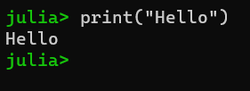

1. Write a Julia program to demonstrate How to assign variables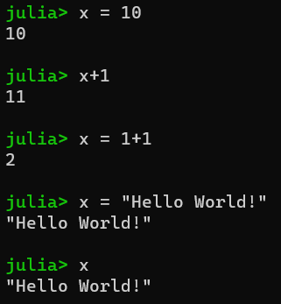
2. Write a Julia program to demonstrate How to comment

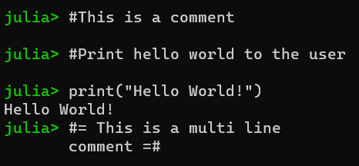

1. Write a Julia program to demonstrate Syntax for basic math

